+

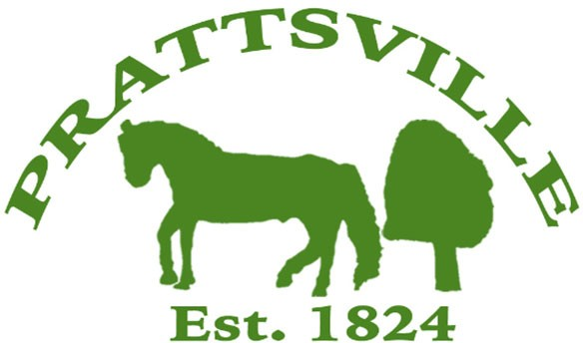Town of Prattsville Board Agenda

Regular Monthly Meeting

July 14th, 2025

1. CALL MEETING TO ORDER
   * Pledge of Allegiance
   * Roll Call
2. APPROVAL OF CLERK'S MINUTES
   * Regular Meeting – June 9th, 2025
3. APPROVAL OF MONTHLY FINANCIAL REPORT
4. COMMENTS FROM THE FLOOR / CORRESPONDENCE FROM THE COMMUNITY

# Reports

1. Highway
2. Water District Report
3. Code Enforcement Monthly Report
4. WWTP Report
5. Tax Collector Report
6. Water billing report
7. Pratt Rock

# New Business

1. Zadock Pratt Museum
2. Mountain Top Coalition
3. Knotweed
4. UTV law
5. Town Use Form
6. Pratt Rock Contract & Resolution