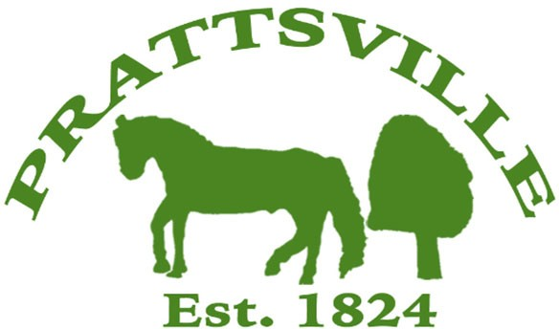
Town of Prattsville Board Agenda
Regular Monthly Meeting
November 10th, 2025

- CALL MEETING TO ORDER
  - Pledge of Allegiance
  - Roll Call
- APPROVAL OF CLERK'S MINUTES
  - Regular Meeting – October 13th, 2025
  - Budget Workshop – October 22nd, 2025

- APPROVAL OF MONTHLY FINANCIAL REPORT
- COMMENTS FROM THE FLOOR / CORRESPONDENCE FROM THE COMMUNITY

Reports
- Highway
- Water District Report
- Code Enforcement Monthly Report
- WWTP Report
- Pratt Rock

New Business

- Water readings
- Water costs
- December Pay
- UTV Local Law
- Resolution to adopt the preliminary budget
- Resolution to schedule the public hearing for the budget

