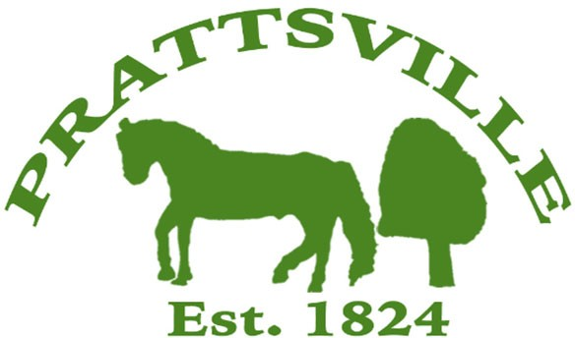
Town of Prattsville Board Agenda
Regular Monthly Meeting
April 8th, 2024

- CALL MEETING TO ORDER
  - Pledge of Allegiance
  - Roll Call
- APPROVAL OF CLERK'S MINUTES
  - Regular Meeting – March 11th, 2024

- APPROVAL OF MONTHLY FINANCIALS REPORT
- COMMENTS FROM THE FLOOR / CORRESPONDENCE FROM THE COMMUNITY

Old Business / Reports
- Highway
- Water District Report
- Code Enforcement Monthly Report
- WWTP Report
- Zadock Pratt Museum Report
- Tax Collector Report

New Business

- Spring Cleanup dates.
- PW application for Water System Improvement Project
- Conine Ballfield Bids
- Handicap Parking Request
- Town Green
- Pratt Rock Contract
- Town Use Forms
- Local Law to Regulate the Notification of Defects
- Ambulance Contract

